Rubric to Prioritize Additional Full-Time Faculty, Counselors, Librarians, and Special Program Coordinators

Subjective Criteria | Data/Data Source |  | Low Priority  0 | 2 | 4 | High Priority  6
1. Program Planning
Instruction, Counseling and Library:  Full-time position supports college priorities, the Master Plan, and program goals. | Information comes from the most recent Program Review report. Presenter provides proposed measurable program accomplishments expected with the full-time faculty member. (e.g., guided pathways, faculty advising, program development into new fields of study/degrees/ certificates) | Presenter shows no evidence to support new full-time faculty member. |  | Presenter requests a full-time faculty member with the outcome related to enrollment increases. | Presenter demonstrates anticipated outcomes (e.g., increase of enrollment, courses developed, partnerships and new awards) associated with hiring full-time faculty member and aligns one Program Review goal/initiative that the full-time position will support. | Presenter comprehensively demonstrates clear and anticipated outcomes (e.g., increase of enrollment, courses developed, partnerships and new awards) related to hiring the full-time faculty member. This information is clearly articulated across more than one Program Review goal/initiative and college plan that the full-time position will support.

Subjective Criteria | Data/Data Source | Low Priority  0 | 2 | 4 | High Priority  6
2. Educational Climate, Job Market and Industry Demand, College Major Trends, and Federal/State/Local Counseling Mandates
Instruction | Presenter may draw from ONET, BLS, Doing What Matters, Launch Board 2.0, general education requirements, data on transfers and majors, articulations, partnerships, and other sources. | Data shows no demonstrable regional or national demand for a major or certificate from this discipline. | Data shows limited regional and/or national demand for a major or certificate from this discipline. | Data shows some regional and national demand for a major or certificate from this discipline. | Multiple data sources show robust regional and national demand for a career or major from this discipline.
Counseling and Library | Presenter may draw from state or federal mandates, local legislation, and other internal / external factors impacting Counseling or Library services. | There is no evidence of new legislation or mandates requiring an additional full-time Counselor or Librarian. | There is limited evidence of new legislation or mandates requiring an additional full-time Counselor or Librarian. | There is some evidence of new legislation or mandates requiring an additional full-time Counselor or Librarian. | There is substantial evidence of new legislation or mandates requiring an additional full-time Counselor or Librarian.

Objective Criteria | Data/Data Source | Low Priority  0 | 1 | 2 | High Priority  3
3. LHEs and Hours
Instruction:  Available LHEs beyond those taught by current full-timers. | LHE data retrieved from the faculty load and compensation (FLAC) database over last two fall and spring semesters. | Discipline requires fewer than 30.0 LHEs per semester by part-time faculty to staff classes. | Discipline requires 30.5-60.0 LHES per semester by part-time faculty to staff classes. | Discipline requires 60.5-90.0 LHES or more per semester by part-time faculty to staff classes. | Discipline requires 90.5 LHES or more per semester by part-time faculty to staff classes.
Counseling:  Need for counseling throughout the academic year. | Hours of counseling and LHE taught by part-time counselors. Data retrieved from the FLAC and SARS databases.  Calculation:  (Counseling hours score + LHE score)/2 | The number declined from the previous year.  Discipline requires fewer than 30.0 LHEs per semester by part-time faculty to staff classes. | The number remained the same or increased up to 2.00% from the previous year.  Discipline requires fewer than 30.0 LHEs per semester by part-time faculty to staff classes. | The number increased by 2.01-5.00% from the previous year.  Discipline requires 60.5-90.0 LHES or more per semester by part-time faculty to staff classes. | The number increased by more than 5.01% from the previous year.  Discipline requires 90.5 LHES or more per semester by part-time faculty to staff classes.
Librarians:  Need for Library support throughout the academic year. | Title 5 of the California Code of Regulations (§ 58724) contains the recommendation for the minimum standards for numbers of library faculty based on student FTES. Coastline FTES 6,192. Recommended (not requirement) is 5 FTEF. | The number of FTEF exceeds the recommendation. | The number of FTEF is between 60.01% and 100.00% of the recommendation | The number of FTEF is between 30.01% and 60.00% of the recommendation | The number of FTEF is 30% or less of the recommendation

Objective Criteria | Data/Data Source | Low Priority  0 | 1 | 2 | High Priority  3
4. Part-Time Load
Instruction:  Percent of sections taught by part-time faculty. | Data from Banner shows discipline’s part-time FTEF ÷ total FTEF, yielding the part-time teaching load percentage. | Fewer than 40% of FTEF are taught by part-time faculty. | 40.01 - 60% of FTEF are taught by part-time faculty. | 60.01 - 80% of FTEF are taught by part-time faculty. | 80.01 -100% of FTEF are taught by part-time faculty.
Counseling:  Percent of counseling appointments by part-time counselors. | Data from SARS shows percent of counseling appointments (Hours) completed by part-time counselors. | Fewer than 40% of counseling appointments (Hours) are completed by part-time counselors. | 40.01 - 60% of counseling appointments (Hours) are completed by part-time counselors. | 60.01 - 80% of counseling appointments (Hours) are completed by part-time counselors. | 80.01 - 100% of counseling appointments (Hours) are completed by part-time counselors.
Library:  Percent of library interactions by part-time librarian. | Data of Library interactions. | Fewer than 40% of library interactions are completed by part-time librarians. | 40.01 - 60% of library interactions are completed by part-time librarians. | 60.01 - 80% of library interactions are completed by part-time librarians. | 80.01 - 100% of library interactions are completed by part-time librarians.

Objective Criteria | Data/Data Source | Low Priority  0 | 1 | 2 | High Priority  3
5. FTES Relative Rankings
Instruction:  Discipline’s total FTES during past four major sessions (fall and spring semesters). | FTES (enrollment) data retrieved from Banner. | Discipline is in the bottom 25% of FTES-generating disciplines. | Discipline is in the 25.01% to 50% range of FTES-generating disciplines. | Discipline is in the 50.1% to 75% range of FTES-generating disciplines. | Discipline is in the 75.01% or higher range of FTES-generating disciplines.
Counseling and Library:  College’s total FTES (enrollment) during past four major sessions (fall and spring semesters). | FTES (enrollment) data retrieved from Banner. | The FTES stayed the same or declined from the previous year. | The FTES increased by 0.01% to 1.00% from the previous year. | The FTES increased by 1.01-5.00% from the previous year. | The FTES increased by more than 5.01% from the previous year.

Objective Criteria | Data/Data Source | Low Priority  0 | 1 | 2 | High Priority  3
6. Student Demand for Sections and Services
Instruction:  Number of sections offered during past two major terms. | Data shows total number of FTES-generating CRNs (sections) for the discipline.  Data retrieved from Banner over last two fall and spring semesters. | Discipline is placed in the bottom 25% based on the number of FTES-generating section | Discipline is placed in the 25.01% to 50% range based on the number of FTES-generating section | Discipline is placed in the 50.1% to 75% range based on the number of FTES-generating section. | Discipline is placed in the 75.01% or higher range based on the number of FTES-generating sections.
Counseling:  Number of students served over past two major terms. | Data reflects a headcount of the number of students who participated in counseling services. Data retrieved from SARS tallying one fall and one spring semester. | The number stayed the same or declined from the previous year. | The number increased by 0.01-1.00% from the previous year. | The number increased by 1.01-5.00% from the previous year. | The number increased by more than 5.01% from the previous year.
Librarians:  Need for Library support throughout the academic year. | Student interactions with the Coastline Library. | The number declined from the previous year. | The number increased by 0.01-10.00% from the previous year. | The number increased by 10.01-25.00% from the previous year. | The number increased by more than 25.00% from the previous year.

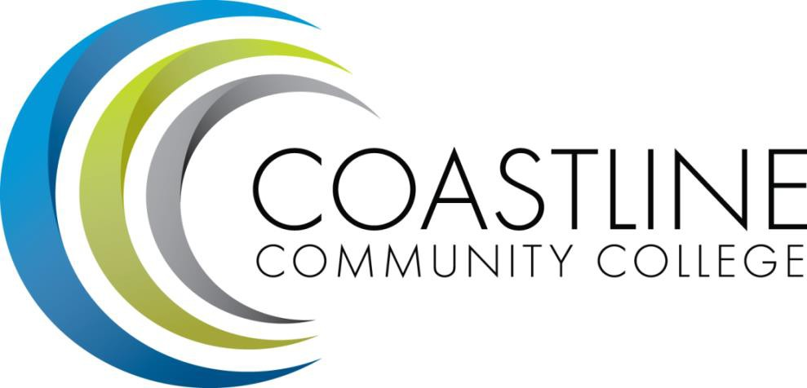
Internal Rating Sheet to Prioritize Additional Full-Time Instructional Faculty Counselors and Librarians 2018 – 2019

#s 1 – 2 = Auto-populated objective scores.  Do not change scores.  3 points possible each. | Discipline A | Discipline B | Discipline C | Discipline D | Discipline E | Discipline F | Etc.
1. Program Planning
2. Educational Climate, Job Market and Industry Demand, College Major Trends, and Federal/State/Local Counseling Mandates
- Subtotal from subjective scores
(12 points possible total)

#s 3 – 6 = Auto-populated objective scores.  Do not change scores.  3 points possible each. | Discipline A | Discipline B | Discipline C | Discipline D | Discipline E | Discipline F | Etc.
3. LHEs and Hours
4. Part-Time Load
5. FTES Relative Rankings
6. Student Demand for Sections and Services
- Subtotal from objective scores
(12 points possible total)

FINAL SCORE = Subtotal A + Subtotal B
(24 points possible)

Mission Statement: Coastline Community College steadfastly focuses on providing access and supporting student success and achievement. Inspired by an innovative and student-centered mindset, Coastline delivers flexible courses and services that cultivate and guide diverse student populations across the globe to complete pathways leading to the attainment of associate degrees, certificates, career readiness, and transfer to four-year colleges/universities.

Faculty Rating Sheet to Prioritize Additional Full-Time Instructional Faculty Counselors and Librarians 2018 – 2019

Subjective scores.  Please score based on presenters’ argument.  6 points possible each statement. | Discipline A | Discipline B | Discipline C | Discipline D | Discipline E | Discipline F | Etc.
Program Planning
Educational Climate, Job Market and Industry Demand, College Major Trends, and Federal/State/Local Counseling Mandates
Subtotal from subjective scores
(12 points possible total)

Mission Statement: Coastline Community College steadfastly focuses on providing access and supporting student success and achievement. Inspired by an innovative and student-centered mindset, Coastline delivers flexible courses and services that cultivate and guide diverse student populations across the globe to complete pathways leading to the attainment of associate degrees, certificates, career readiness, and transfer to four-year colleges/universities.

